**CLOUD COMPUTING PROJECT**

**(2020-21)**

**Car Selling Price Prediction**

**Group No - 8**

**SYNOPSIS**



**GLA University, Mathura**

**Team Members**

Manish Gautam

(181500366)

Nikhil Baghel

(181500424)

Shreshtha Tola

(181500688)

***Supervised By***

**Mr. Vivek Sharma**

**Assistant Professor**

**Department of Computer Engineering & Applications**

**About the Project:**

The Car Selling Price prediction is a Machine Learning Model used to predict the selling price of any car with high accuracy rate and least error (MSE) and validates the output using various train and test features such as:

* Car’s release date,
* No of previous owners that used the car,
* The latest showroom price,
* Distance travelled by the car until now(kilometers)
* Input Fuel Type (Petrol/Diesel/Gas)
* Transmission Type (Automatic/Manual)

By implementing various Machine Learning algorithms to Train and test the model, some of the libraries used are numpy, sklearn, pandas, jsonify, scipy, etc. and algorithms used are one-hot encoding, Regression, Classification and NPL and more.

After the model is well trained and tested it is further deployed of cloud using the various Cloud Platforms such as Heroku Cloud, AWS Cloud, Microsoft Azure Cloud or Google Cloud.

**Motivation Behind:**

The objective/motivation behind this project was to create and deploying a cloud project which may give a good and accurate car selling price prediction using various ML algorithms and to display out with the least error(known as Mean Squared Error) in prediction rate.

From the past learning and implementation in AI ML models to predict output based on various features given or provided in the model to train and test we implemented this Project.

**Future Scope:**

The future scope for this project is to go out there and start looking up different software vendors or end users right away to use this as the web app or software application in order to predict car selling price based on various features provided that the model is already well trained and tested to just predict the selling price of any car irrespective of car size or version model.

**Requirements:**

* **Hardware:**
* RAM - 4GB or above
* Processor - intel i3 or above / Ryzen3 or above
* Hard Disk - 40GB or above
* **Software:**
* Backend - Flask
* Technology Used – Machine Learning, Cloud Computing
* Dataset – Sklearn/Kaggle
* Language used – Python
* Frontend Design – HTML,CSS
* Cloud Platform – Heroku or AWS Cloud
* Environment – Anaconda 3 (64-bit)
* Operating System - Windows 7 or above/Linux/MacOS

**Software Design:**

**Use-Case Diagram**: 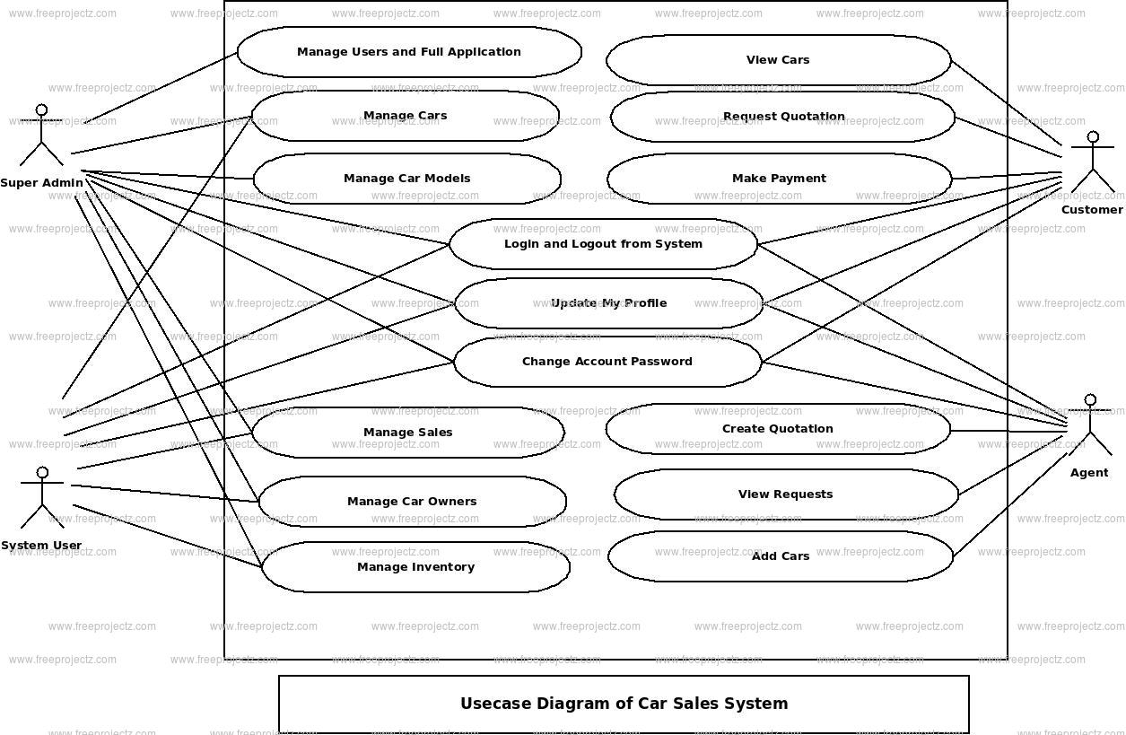

**UML Diagram:**

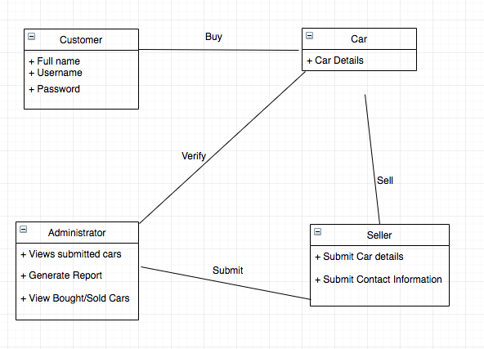

**Entity Relationship Diagram**

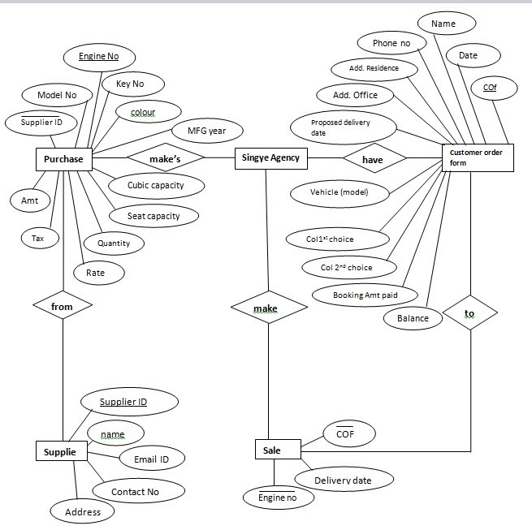

**Sequence Diagram**

